Alan Dapré: Media Assets/Info
Contact details & Location:
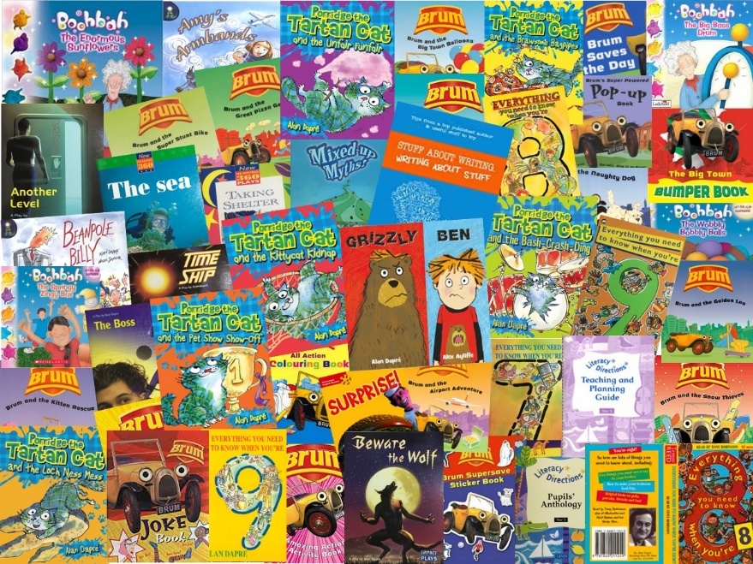
Alan Dapré
07979756693
alandapre@gmail.com
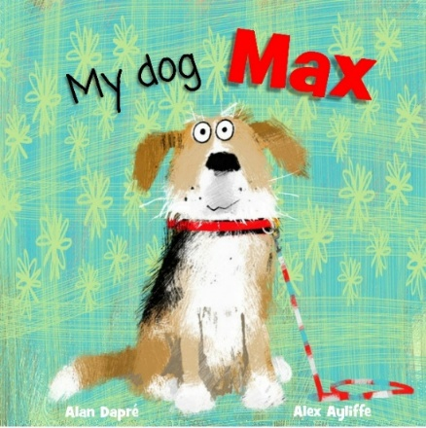
North Ayrshire based

Style:
Alan Dapré’s style is playful, humorous, and full of energy, often using quirky characters, unexpected twists, and a strong sense of rhythm.
Latest Title: My dog Max
When a little girl meets Max at the Doggy Den, she can't stop thinking about him! She would LOVE to give Max a happy home...but will the grown ups agree? So many dogs, but there's only one Max.
Bio:
Based in Scotland, Alan Dapré is an author and playwright, best known for his contributions to children's literature and television. He has written 63 books for young readers, including the popular 'Porridge the Tartan Cat' series. His works quite often incorporate elements of Scottish culture and are characterized by their engaging storytelling and playful language.
Alan Dapré has written across a range of genres. In addition to his books, Alan has written over one hundred scripts for children's television shows - such as BAFTA nominated Brum and Boohbah - further highlighting his versatility in creating content that resonates with young audiences.
His plays have been on BBC Radio and published for use in schools. A former TV scriptwriter, Alan now spends his time writing funny and engaging children's books, including ‘My dog Max’ – his latest picture book about a girl who really wants a dog!
Alan’s extensive body of work reflects his dedication to entertaining and educating children through various media.​
Alan in his own words:
“I spent my early years in a foster home, before entering various children's homes. The noise and rules took a lot of getting used to, so I took comfort in books.
Stories sent my imagination soaring. I was free to roam new worlds and words. I discovered the fun of rhythm, rhyme and reading out loud.
A turbulent time at boarding school followed, where I was singled out and bullied for my Care background and appearance; having long outgrown my school uniform.
Provision for children in my situation was patchy. More positively, in my final year, I won prizes for Art and Drama, and this spurred me on to go to university. One of the first children from Care ever to do so.
Mid-1980s, I studied Creative Arts then took a PGCE at Nottingham Trent University. Determined to give something back and prove that school can be an empathetic experience, I taught Primary age children and, in time, became a Deputy Headteacher.
I wrote my first play for Radio 4 while teaching. At the turn of the millennium, I left and started originating, writing & producing for a TV production company, on shows such as Brum, Boohbah, Blips & Tronji.
I subsequently moved to Scotland and began freelancing; writing chapter books and picture books. These days, I combine writing with author events. I aim to share my stories in an accessible way, with wordplay, props and participation; tailoring elements for each audience.
I regularly visit book festivals, libraries and schools, where I deliver lively interactive events based on my published books, and childhood experiences in Care."
Typical Author Event description:
Alan Dapré shares My dog Max, his latest picture book about a determined girl who really wants a dog! A hilarious story of hope, home and happiness. Filled with fun, awesome illustrations, and read aloud rhymes. Expect props, laughter and much more!
Links to previous work:
More available on his News Reviews Interviews webpage at www.alandapre.com:
https://www.scottishbooktrust.com/articles/alan-dapre-explores-the-power-of-picture-books
https://www.letterpressproject.co.uk/media/file/Alan_Dapre.pdf
https://en.wikipedia.org/wiki/Alan_Dapre
